SECTION 10
Deal Recap
Saturn Dealer Management System | Finance & Insurance (F&I) Module
Audience  F&I Managers | Module  Deal Recap | Integration  RouteOne | Document Type  User Reference Guide

Table of Contents

Table of Contents 1
1. Overview 2
2. Accessing Deal Recap 2
3. Deal Recap Components 2
4. Critical Delivery Question - eContracting 5
Question 1: Will the Finance Contract Be eContracted? 5
5. eContracting Process 5
5.1 eContracting Workflow 5
5.2 Document Status Indicators 7
6. Quality Control Checklists 7
6.1 Pre-Finalization Checklist 7
6.2 eContract Validation Checklist 7
6.3 Document Review Checklist 7
7. Troubleshooting 8
8. Best Practices 8
9. Key Takeaways 9
10. Deal Recap Infographic 10

1. Overview
The Deal Recap section is the final review checkpoint before deal completion. F&I managers use this section to verify accuracy, initiate eContracting, and prepare the deal for accounting and posting.

Purpose  - Provides a complete transaction overview in one location  - Serves as the final quality control checkpoint  - Ensures all sections are accurate and complete  - Facilitates management review and approval  - Prepares the deal for accounting and final posting | Primary Users  - F&I Managers: Final verification before closing  - Sales Managers: Review and approval  - Finance Teams: Accounting and posting review

2. Accessing Deal Recap
Follow these steps to access the Deal Recap section within Saturn DMS.

Step | Action | Details
1 | Open Deal Record | Navigate to the active deal record in Saturn DMS.
2 | Navigate to Deal Recap | Click on the Deal Recap or Summary section from the deal navigation menu.
3 | Review Before Finalizing | This section is typically the last step accessed before deal finalization.

3. Deal Recap Components

The Deal Recap displays eight critical sections. Review each section carefully before proceeding to finalization.

# | Component | Description | Key Action
1 | Deal Employees | Lists all team members involved: salesperson, sales manager, and F&I manager. | Verify all employee assignments are correct.

2 | Vehicle Information | Confirms year, make, model, VIN, and all vehicle-specific details. | Review carefully. Errors cause significant delays.
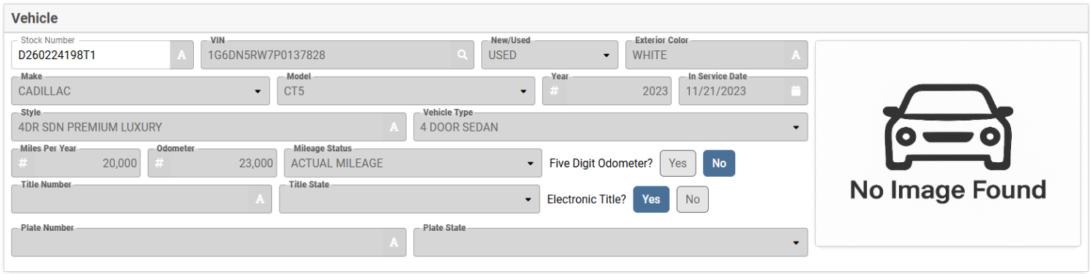
3 | Insurance Information | Verifies insurance provider, NAIC number, policy number, and coverage details. | Confirm coverage meets lender and state requirements.
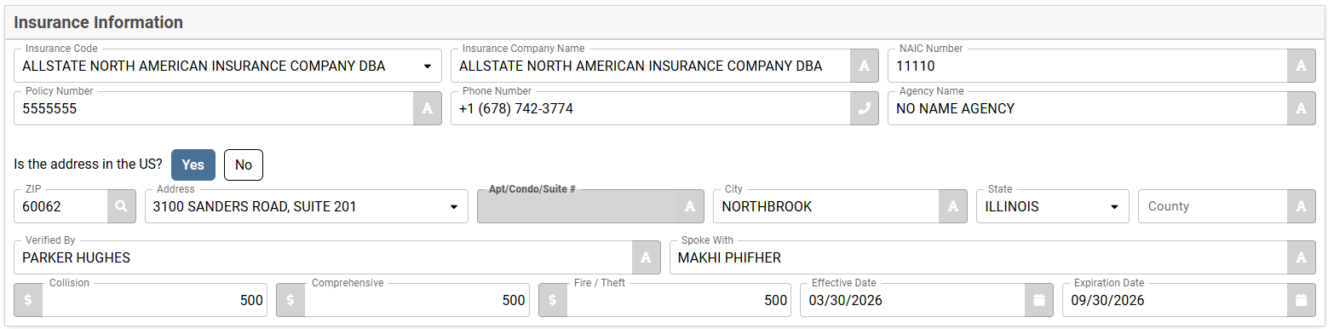
4 | Buyer's Order | Displays an itemized purchase breakdown, including vehicle price, taxes, and fees. | Verify all amounts match the customer agreement.
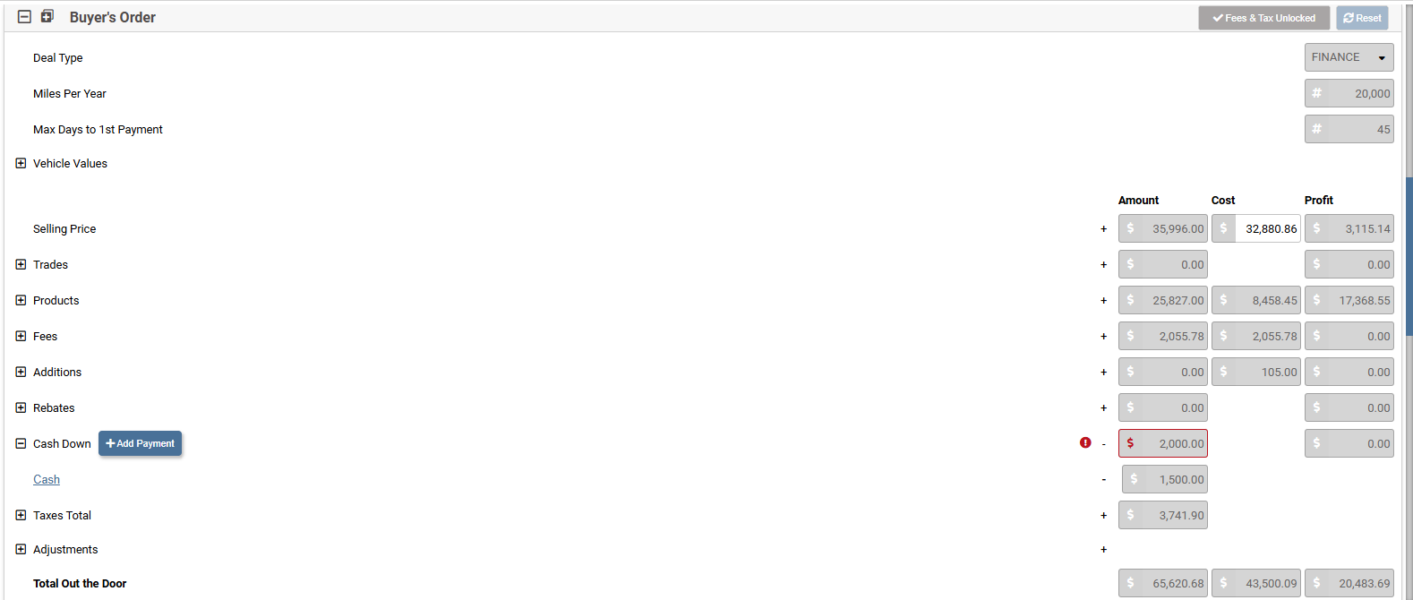

5 | Retail Summary | Discloses the loan information, monthly payment, term, buy rate, sell rate, days to 1st payment, and first payment date. | Confirm the loan amount with the customer.
6 | Front End Gross | Shows profit from the vehicle sale: selling price minus dealer cost. | Review for accuracy and profitability.
7 | Back End Gross | Displays F&I product profit: extended warranties, GAP insurance, and protection plans. | Confirm all products are accurately reflected.
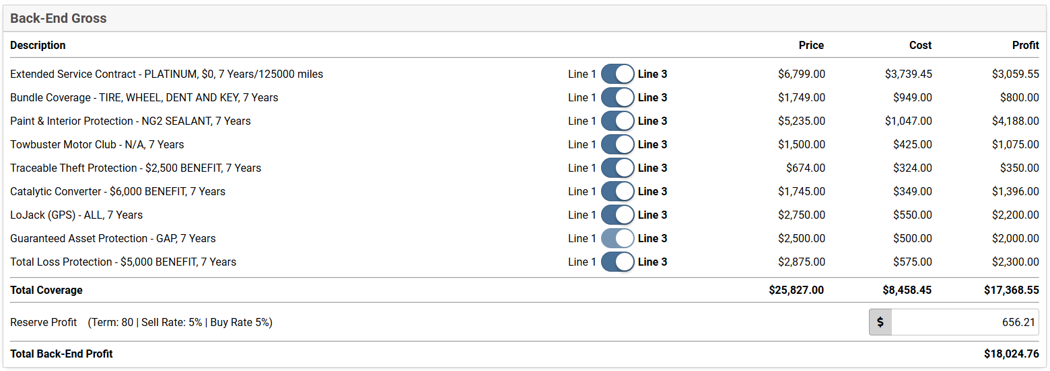
8 | Totals | Combines front-end and back-end gross profit. Shows total dealership profit. | Verify grand total matches all line items.
9 | eContract: Critical Question | One yes/no question that determines delivery status and eContracting activation. | Answer the question before proceeding.
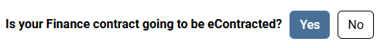

4. Critical Delivery Question - eContracting

At the bottom of the deal recap, the F&I manager answers a question. This question determines the next steps in the deal process.

Question 1: Will the Finance Contract Be eContracted?
This determines if the contract will be signed electronically rather than on paper.

Response | Result
YES | The eContracting workflow activates. The system integrates with RouteOne for electronic signature management.
NO | Paper-based contract process is used. Standard physical document workflow applies.

5. eContracting Process

The eContracting process begins at the end of the F&I Menu and continues through the Deal Recap. Electronic contracting streamlines document signing and speeds up deal completion.

Saturn integrates with RouteOne to manage the electronic signing workflow.

NOTE: The eContracting process requires an active RouteOne connection. Ensure your dealership's RouteOne account is configured before initiating this workflow.

5.1 eContracting Workflow

Step | Action | Description | Outcome
1 | Initiate eContract Flow | Answer YES to eContracting. A workflow panel displays on the recap page. | eContract panel is active.
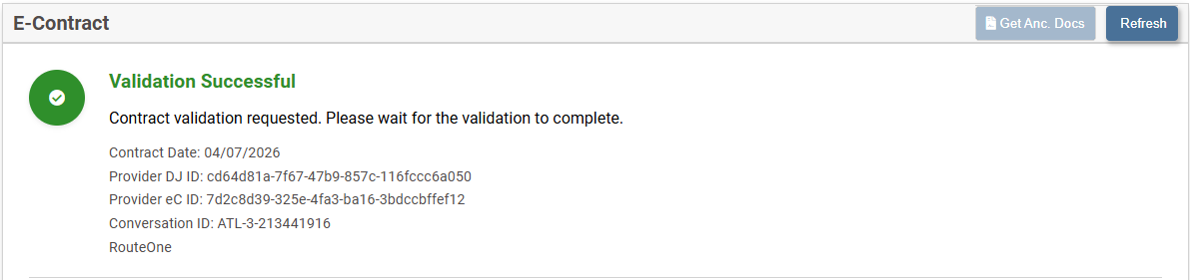
2 | Validate eContract | Click the Validate eContract link. Saturn sends deal information to RouteOne for validation against lender rules. | Validation succeeds or errors display.
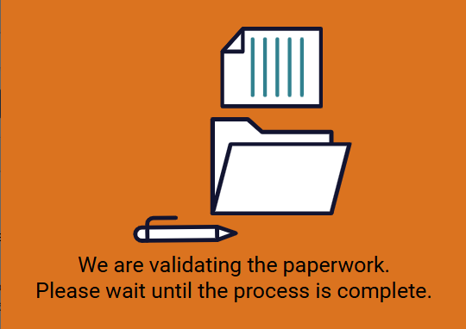
3 | Generate Paperwork | After successful validation, Saturn calls RouteOne to fetch all required documents. Documents import into Saturn automatically. | All documents appear in the deal jacket.

4 | Access Deal Jacket | Navigate to the Deal Jacket section. Documents are organized in Active, Voided, and Other Documents folders. | Documents are ready for signing.
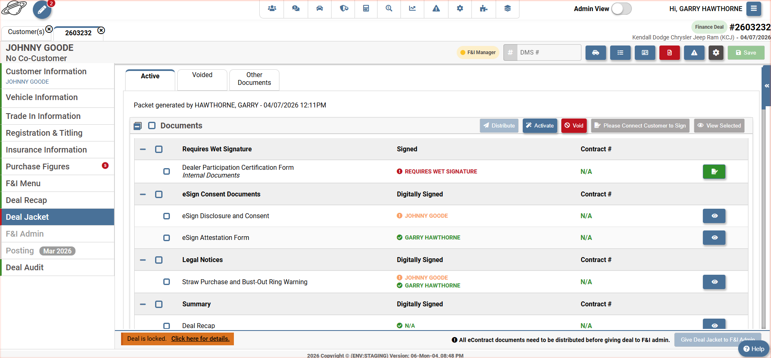

5.2 Document Status Indicators

Status | Meaning
Green Checkmark | Document was successfully transmitted to RouteOne. No action required.
Exclamation Mark | Document was not transmitted. This may occur if documents were added after initial sending. Resend before finalizing.

6. Quality Control Checklists

Use these checklists before finalizing any deal. All items must be confirmed before proceeding.

6.1 Pre-Finalization Checklist
- Verify all deal information for accuracy
- Confirm all eight deal recap components are complete
- Verify all calculations and totals are accurate.
- Confirm customer and vehicle information are correct
- Ensure insurance details meet lender and state requirements
- Address all system warnings or missing item notifications
- Validate financial accuracy across all sections

6.2 eContract Validation Checklist
- Validate eContract before generating paperwork
- Resolve all validation errors before proceeding
- Confirm all required documents are generated and in the Deal Jacket
- Verify all signatures are captured before sending to fund
- Check all document status indicators show green checkmarks.
- Confirm the Deal Checklist is 100% complete.

6.3 Document Review Checklist
- Review every section carefully before finalizing
- Ensure all required documents are uploaded.
- Verify document totals match the customer agreement
- Keep detailed notes about any special circumstances

7. Troubleshooting

Refer to this section to resolve common issues during the Deal Recap and eContracting process.

Issue | Problem | Resolution Steps
Validation Errors | Validation fails when clicking Validate eContract. | - Review error messages in the panel.  - Identify which fields need correction.  - Navigate to the relevant section.  - Correct all errors.  - Return to Deal Recap and validate again.
Deal Recap Discrepancies | Numbers in Deal Recap do not match the customer agreement. | - Compare the Deal Recap with the original quote.  - Verify vehicle information matches.  - Check the buyer’s order line by line.  - Verify tax and fee calculations.  - Contact the responsible party for corrections.  - Regenerate the Deal Recap after corrections.

8. Best Practices

Before eContracting  • Review all Deal Recap sections thoroughly  • Verify all calculations and totals  • Confirm customer and vehicle information  • Ensure insurance details are complete and accurate | During eContracting  • Address all system warnings immediately  • Keep notes about special circumstances  • Validate eContract before generating paperwork  • Resolve all validation errors before proceeding

9. Key Takeaways

1. A deal recap is the final quality checkpoint before transaction completion.
2. All eight components must be verified before answering the critical delivery questions.
3. One yes/no question activates delivery and eContracting workflows.
4. eContracting automates validation, paperwork generation, and signature management through RouteOne.
5. The Deal Jacket will be the next phase in Saturn, where the customer will begin the e-signing process.
6. Green checkmarks confirm successful document transmission to the lender.
7. All validation errors must be resolved before paperwork can be generated.

Summary
The Deal Recap and e-contracting process ensure accurate, complete transactions. F&I managers serve as the final quality checkpoint before deal completion.
By following this guide, F&I managers can efficiently initiate eContracting, validate deal information, generate paperwork, manage signatures, and submit complete deal packets to lenders. Proper execution protects the dealership legally, ensures customer satisfaction, and maintains full regulatory compliance. To complete the process, the next step will lead you to the Deal Jacket, where the e-signature process begins, to ensure all documentation is entered into Saturn prior to the customer closing on the deal.

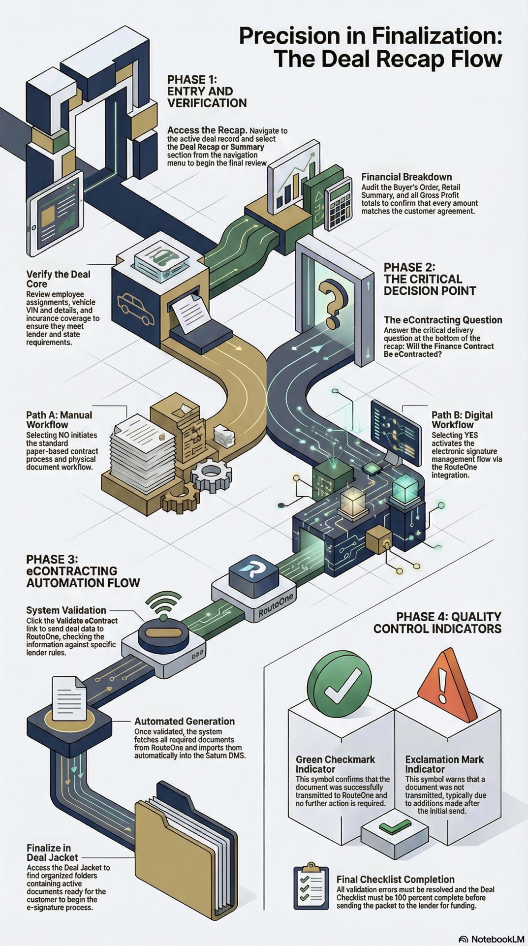
10. Deal Recap Infographic

